Summary
Situation and research objectives
From March 2022 to February 2024, 127 initiatives in Flanders and 6 initiatives in Brussels have been working on caring neighbourhoods (in the broader framework of ‘integrated community care’). The Department of Care (formerly 'Department of Welfare, Public Health & Family') describes this concept as follows:
"In a caring neighbourhood, conditions are met so that people, regardless of age and major or minor support needs in different areas of life, can (continue to) live comfortably in their home or familiar neighbourhood. It is a neighbourhood where young and old live together, where people feel good and safe, where quality of life is central, where residents know and help each other, where individuals and families with major and minor support needs are supported and where services and facilities are accessible and available" (Flemish Government, 2021, p. 5).
According to this description, a caring neighbourhood initiative consists of three core concepts: (1) participatory work with the neighbourhood, (2) establishing links between informal and formal care, and (3) welfare and care partners working together with other partners in a network aimed at prevention, health promotion and the provision of integrated care and support with a focus on quality of life (Flemish government, 2021).
The 133 (later 132) recognised initiatives were subsidised by the Department of Care and received support coordinated by the King Baudouin Foundation (KBS). In addition, a team of researchers monitored the practical implementation to identify incentives and barriers to the development of a caring neighbourhood. Based on these findings, they developed a toolbox consisting of practical methods that can support actors in the field (care organisations, care boards, local administrations...) in working towards a caring neighbourhood. The researchers drew up a series of policy recommendations aimed at the different policy levels involved: federal, Flemish, supralocal and local, both on an administrative and executive level.
Method
At the beginning of our two years of research, an framework was developed, looking at what was already known about caring communities at the time. A literature review and focus groups with academics, policy-makers and field workers were used to define objectives and critical success factors.
The objectives and critical success factors can be divided into two groups: (1) outcome objectives, and (2) process objectives. Outcome objectives refer to long-term goals or ambitions of caring neighbourhoods. The five outcome objectives are: "improving quality of life", "strengthening social cohesion", "encounters between neighbours", "strengthening co-reliance", and "detecting and signalling". In contrast, the process objectives deal with how to work on caring neighbourhoods. The seven process objectives are: "coordinated cooperation", "having a dedicated team", "increasing accessibility", "communicating adequately", having a support base", "increasing sustainability of integrated community care ", and "co-development". This framework further underpinned the second major component of the study: learning from practice.
Three rounds of research explored the experiences of the caring neighbourhood projects and their coaches, in order to identify potential barriers and enablers. Each round of research consisted of three components: (1) focus groups with the project staff, (2) focus groups with coaches, and (3) short, online questionnaires. Each round focused on a different topic (governance, process and outcomes), based on the CAIMeR model (Blom & Morén, 2010).
Figure 2 Components of the research rounds
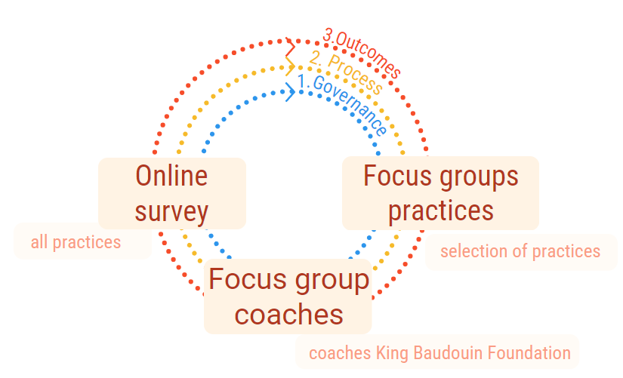
Source: the authors
A neighbourhood typology was developed to gain insight into the different types of caring neighbourhoods in Brussels and Flanders. Based on the data from the 132 caring neighbourhood projects, a data file was created and a hierarchical cluster analysis was carried out to distinguish clusters. Based on practical experience, it became clear "who needs what, in what context".
Conclusions and policy recommendations
Barriers and enablers related to the three core concepts of caring neighbourhoods
The first core concept, participation and inclusion, relates to building social fabric and solidarity. Caring neighbourhoods focus on relational effects between neighbourhood residents, but also on outreach and involvement. However, there is the issue of the extent to which everyone wants to be reached and involved, emphasising the option of non-engagement.
The second core concept focuses on the link between formal and informal care, which is seen as necessary for the (early) identification of care and support needs, prevention of health inequalities and the support for informal carers. A positive development was observed: the trust of the neighbourhood and professionals in the process increased, and local residents found their way to formal care and support more quickly. However, it was also observed that there were still essentially two separate tracks being followed. Building a network and linking formal and informal care is a time-consuming process. This was not in line with the two-year duration of the project. Time was therefore described as a barrier, while equal cooperation was described as an incentive, requiring trust and open communication.
The third component, intersectoral cooperation, concerns the networking of welfare and care partners together with other partners from other sectors. A positive development was also observed within this component: reciprocity between partners had increased. Embedding the concept of caring neighbourhoods in one’s own work and organisation was described as a stimulus. There was also a change in mentality among the partners, recognising the importance of working in the neighbourhood and being present in the neighbourhood. The development of a shared vision and common goals contributes to this. The presence of permanent professional focal points with a mandate was identified here as a stimulus for networking, which can develop a common language with different stakeholders . The third section refers to the impact of cooperation on people's quality of life. However, competitive feelings and the time required are obstacles to its realisation.
If we look at the achievements formulated so far, they are mainly situated in the first core concept, i.e. building social capital. The other two components, linking informal and formal care and intersectoral cooperation, have been less discussed. This may be explained, among other things, by the time investment required for these two components and the influence of competitive feelings between organisations.
The goals originally formulated by the caring neighbourhoods are in line with the achievements. Several of these correspond to priorities from the assessment framework, but underlying elements such as 'equity' and 'realisation of fundamental social rights' are less addressed in practice. The added value of a more equitable geographical distribution of needs and demands in society, such as community support, access to health services, and a healthy and welcoming public space, was also highlighted from the perspective of 'socio-spatial justice' or the 'socio-spatial justice principle'. The further roll-out of caring neighbourhoods in Flanders and Brussels should therefore take into account potential spatial inequalities. After the project period, many caring neighbourhoods planned to continue their activities in some way (surveyed for the possibility of extending funding). The ways in which the activities would continue varied considerably.
Incentives and barriers in the process of working towards a caring neighbourhood
It was also found that caring neighbourhoods require a process-oriented way of working. Caring neighbourhoods can be achieved in various geographical contexts, with varying pre-determined goals and actors. The extent to which actions or interventions were successful depended on the process undertaken with all the actors involved. Looking back on this process, we can identify some obstacles and incentives.
First, the broad scope of caring neighbourhoods was described as both a barrier and an incentive. On the one hand it offered freedom and room for experimentation but on the other hand it also created uncertainty about the employee's job performance and future.
In addition, the different actors involved, may have different roles and tasks. Depending on the intended activity or relational effect, a different scale may be relevant.
- Conducting a participatory neighbourhood analysis is a stimulus here, as it can be used as a tool to engage in a co-creative process with local residents. It is part of an ongoing process.
- Aligned collaboration can be a stimulus, as a co-creative process that achieves a common language and supported vision, enhances the functioning of a caring neighbourhood.
- In addition, the added value of training, coaching and peer review was described as stimulating, as it provided recognition, appreciation and affirmation and brought new perspectives.
- The availability of public space and a physical meeting place can be both an incentive and a barrier. On the one hand, it provides a place for people to meet, both indoors and outdoors, but some meeting spaces are in need of renovation or are associated with certain prejudices.
- the involvement of local government can be both a barrier and an advantage. A barrier, because of the cumbersome decision-making process, and an advantage because of the supportive and facilitating role that local government can play.
- Another obstacle is the (lack of) familiarity with the concept of caring neighbourhoods, as it was argued that better familiarity with the concept in society and organisations could facilitate the process of caring neighbourhoods.
- Another obstacle is the legal framework in terms of privacy and language laws, as this complicates the aim of referral and matching.
- The possible effects or outcomes of the caring neighbourhoods are both direct and indirect and difficult or impossible to quantify (quickly). However, it is beneficial to gain insight into the impact of the actions taken. Measurability is therefore both an obstacle and an incentive.

Towards a toolbox and policy recommendations
The barriers and incentives identified form the basis of both the toolbox and the policy recommendations.
The first research objective focused on developing of a toolbox of guidelines or tools that are manageable and easy to use for initiators of caring neighbourhoods. These have been compiled in an interactive pdf, consisting of two main parts: (1) a generic part, (2) several thematic sheets. The generic part contains general information, while the thematic sheets focus on a specific topic. They provide an overview of the main findings of the research and related materials, methodologies, training, etc.. Signposts have been developed to guide the reader to relevant topics.
The second research objective focused on policy recommendations for the Flemish, supra-local and local administrative and executive levels. In addition to policy recommendations regarding the administrative levels (local and Flemish), the recommendations also deal with elements that can improve the implementation of caring communities at all administrative and executive levels.
Firstly, policy recommendations can be formulated with regard to the Flemish policy level. These deal with:
- the development of a clear long-term vision on the national level, with clear goals. It should be clear where we want to go and what the key issues are. These give direction to local caring neighbourhoods. And it can also help make the work sustainable. It provides a framework to which the work can relate.
- the development of a coordinated nota, working towards role clarification and division of labour: Based on the long-term vision, different policy areas and levels need to be well coordinated. Caring neighbourhoods cut across many policy areas. Neighbourhood work is on the rise, not only in care but also in other policy areas (e.g. environment).
In addition caring neighbourhoods takes place at different geographical levels. Not only the neighbourhood, but also local authorities, supra-local organisations and the Flemish or federal level. There is therefore a need for better coordination and a clear division of roles. So that people can work in a complementary way.
It must be clear who has to do what, but also who is willing and able to do what. In other words, it should be clear what is expected of everyone. Clear agreements on this can also strengthen people in their tasks and provide them with a clear mandate.
- taking into account social and spatial inequalities in the further development: the current projects form a big group of pilot projects that accelerated a lot of initiatives. Several other initiatives are in underway. It is a task not to lose sight of certain communities or neighbourhoods. Make sure that all neighbourhoods are in focus, and none are forgotten. This also means paying special attention to the neighbourhoods that need it most.
Neighbourhood analysis is one way of doing this. There are already a number of organisations that are obliged to map their neighbourhoods. For example, the primary care zones carry out a environmental analysis or the local service centres prepare a neighbourhood analysis. It is therefore necessary to look at how existing policy instruments can be used area-wide, to have and maintain an eye on all possible neighbourhoods. It is also important to keep an eye on social inequalities within the neighbourhoods. Continue to focus on those most in need.
- encourage collaboration,
- provide a mandate with degrees of freedom for the caring neighbourhood staff: Working on caring neighbourhoods is working on a process, and this requires connecting professionals. As a government, you can facilitate this by giving them a clear mandate, but with sufficient freedom, support and room to maneuver. Employers need to look for skills that may already exist within theorganisation.
- the importance of physical meeting places, both indoor and outdoor: Policies on the multifunctional use of infrastructure should be identified and further coordinated. After all, this infrastructure facilitates both meetings between residents and cooperation between partners. It does not always have to be a fixed location; in many cases, materials for organising meeting places (such as standing tables, a bicycle trailer, a mobile home) are sufficient. The multifunctional use of infrastructure (as in the case of community schools) is a possible avenue to explore further. The different regulations need to be identified and further harmonised.
- GDPR and privacy,
- The measurability of the direct and indirect effects or impacts of a caring neighbourhood.

Policy recommendations can then be formulated at the local policy level in relation to:
- embedding the concept in local social policy
- embedding the concept in the local government's multi-year plan
- focus on multifunctional meeting places
- using a professional hub as a necessary condition

The policy recommendations deal with the alignment of the Flemish policy on caring communities with the federal policy level, and with the joint community commission of Brussels for the further development of caring communities.
Finally, recommendations can be made for the supra-local or umbrella level. This does not have a policy function, but can work to stimulate, facilitate and support caring neighbourhoods through consultation, training and coaching.

Full research report: Steurs, M., Wouters, M., Gryp, D., Heylen, L., Verté, D., Van Royen, P. & E., Verté. (2024) De uitwerking van praktische handvatten om buurten te ondersteunen bij de ontwikkeling van een duurzame zorgzame buurt en het geven van concrete beleidsaanbevelingen. Leuven: Steunpunt Welzijn, Volksgezondheid en Gezin.

One project ceased project operation.

